**Instructions**

**Pearson Edexcel**

**Level 1/Level 2 GCSE (9–1)**

Centre Number

Candidate Number

Total Marks

**You must have:**

Ruler graduated in centimetres and millimetres,

protractor, pair of compasses, pen, HB pencil, eraser, calculator.

Tracing paper may be used.

**Mathematics**

**Paper 2 (Calculator)**

**Higher Tier**

Morning (Time: 1 hour 30 minutes)

Paper Reference

**1**

**MA1/2H**

**Thursday 6 June 2019**

Candidate surname

**Please check the examination details below before entering your candidate information**

Other names

* Use **black** ink or ball-point pen.
* **Fill in the boxes** at the top of this page with your name, centre number and candidate number.
* Answer **all** questions.
* 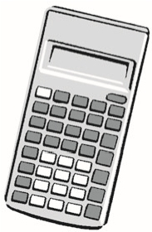Answer the questions in the spaces provided

– *there may be more space than you need*.

* You must **show all your working**.
* Diagrams are **NOT** accurately drawn, unless otherwise indicated.
* **Calculators may be used.**
* If your calculator does not have a *ʌ* button, take the value of *ʌ* to be

3.142 unless the question instructs otherwise.

# **Information**

* The total mark for this paper is 80
* The marks for **each** question are shown in brackets

*– use this as a guide as to how much time to spend on each question.*

# **Advice**

* Read each question carefully before you start to answer it.
* Keep an eye on the time.
* Try to answer every question.
* Check your answers if you have time at the end.

# P54214A *P54214A0120*

***Turn over***

©2019 Pearson Education Ltd.

6/6/1/1/1/1/1/

**Answer ALL questions.**

**Write your answers in the spaces provided.**

**You must write down all the stages in your working. 1** (a) Solve 14*n* 11*n* + 6



.......................................................

## (2)



(b) On the number line below, show the set of values of *x* for which –2 *x* + 3 - 4



**DO NOT WRITE IN THIS AREA DO NOT WRITE IN THIS AREA DO NOT WRITE IN THIS AREA**



–6 –5 –4 –3 –2 –1 0 1 2 3 4 5 6 *x*

## (3)



**(Total for Question 1 is 5 marks)**

# *P54214A0220*

1. On the grid below, draw the graph of *y* = 2*x* – 3 for values of *x* from -2 to 4



**DO NOT WRITE IN THIS AREA DO NOT WRITE IN THIS AREA DO NOT WRITE IN THIS AREA**



*x*

*y*

*O*

1

2

3

4

–1

–2

6

4

2

–2

–4

–8

–6

5

3

1

–7

–5

–3

–1

**(**

**Total for Question 2 is 3 marks**

**)**



*P54214A0320*

1. Hannah is planning a day trip for 195 students.

She asks a sample of 30 students where they want to go. Each student chooses one place.

The table shows information about her results.

|  |  |
| --- | --- |
| **Place** | **Number of students** |
| Theme Park | 10 |
| Theatre | 5 |
| Sports Centre | 8 |
| Seaside | 7 |

(i) Work out how many of the 195 students you think will want to go to the Theme Park.



**DO NOT WRITE IN THIS AREA DO NOT WRITE IN THIS AREA DO NOT WRITE IN THIS AREA**

.......................................................

## (2)



(ii) State any assumption you made **and** explain how this may affect your answer.



..................................................................................................................................................................................................................................................



..................................................................................................................................................................................................................................................



..................................................................................................................................................................................................................................................

## (1)



**(Total for Question 3 is 3 marks)**

# *P54214A0420*

**4** A container is in the shape of a cuboid.

30

cm

19

cm

6

cm

The container is  full of water.

A cup holds 275 m*l* of water.

What is the greatest number of cups that can be completely filled with water from the container?



**DO NOT WRITE IN THIS AREA DO NOT WRITE IN THIS AREA DO NOT WRITE IN THIS AREA**

.......................................................

**(Total for Question 4 is 4 marks)**

# *P54214A0520*

1. *ABC* is a right-angled triangle.

16

cm

*A*

*B*

*C*

38

°

Calculate the length of *AB*.

Give your answer correct to 2 decimal places.

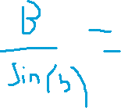

.......................................................cm



**DO NOT WRITE IN THIS AREA DO NOT WRITE IN THIS AREA DO NOT WRITE IN THIS AREA**

**(Total for Question 5 is 2 marks)**



1. Sally used her calculator to work out the value of a number *y*.

The answer on her calculator display began

8.3

Complete the error interval for *y*.

............................ - *y* ............................

**(Total for Question 6 is 2 marks)**

# *P54214A0620*

1. £360 is shared between Abby, Ben, Chloe and Denesh.

The ratio of the amount Abby gets to the amount Ben gets is 2 : 7

Chloe and Denesh each get 1.5 times the amount Abby gets.

Work out the amount of money that Ben gets.



**DO NOT WRITE IN THIS AREA DO NOT WRITE IN THIS AREA DO NOT WRITE IN THIS AREA**

£.......................................................

**(Total for Question 7 is 4 marks)**



1. (a) Write 0.00562 in standard form.



.......................................................

## (1)

(b) Write 1.452 × 103 as an ordinary number.



.......................................................

## (1)

**(Total for Question 8 is 2 marks)**



# *P54214A0720*

**9** The circumference of circle **B** is 90% of the circumference of circle **A**.

(a) Find the ratio of the area of circle **A** to the area of circle **B**.

.......................................................

## (2)

Square **E** has sides of length *e* cm. Square **F** has sides of length *f* cm.

The area of square **E** is 44% greater than the area of square **F**. (b) Work out the ratio *e* : *f*



**DO NOT WRITE IN THIS AREA DO NOT WRITE IN THIS AREA DO NOT WRITE IN THIS AREA**

.......................................................

## (2)

**(Total for Question 9 is 4 marks)**

# *P54214A0820*

**10** Mary travels to work by train every day.

The probability that her train will be late on any day is 0.15

(a) Complete the probability tree diagram for Thursday and Friday.

**Thursday Friday**



**DO NOT WRITE IN THIS AREA DO NOT WRITE IN THIS AREA DO NOT WRITE IN THIS AREA**



late

not late

....................

....................

late

not late

....................

0.15

late

not late

....................

....................

## (2)



(b) Work out the probability that her train will be late on at least one of these two days.



.......................................................

## (3)



**(Total for Question 10 is 5 marks)**

# *P54214A0920*

**11**  The grouped frequency table gives information about the times, in minutes, that 80 office workers take to get to work.

|  |  |
| --- | --- |
| **Time (*t* minutes)** | **Frequency** |
| 0 *t* - 20 | 5 |
| 20 *t* - 40 | 30 |
| 40 *t* - 60 | 20 |
| 60 *t* - 80 | 15 |
| 80 *t* - 100 | 8 |
| 100 *t* - 120 | 2 |

(a) Complete the cumulative frequency table.



**DO NOT WRITE IN THIS AREA DO NOT WRITE IN THIS AREA DO NOT WRITE IN THIS AREA**

|  |  |
| --- | --- |
| **Time (*t* minutes)** | **Cumulative frequency** |
| 0 *t* - 20 |  |
| 0 *t* - 40 |  |
| 0 *t* - 60 |  |
| 0 *t* - 80 |  |
| 0 *t* - 100 |  |
| 0 *t* - 120 |  |

**(1)**



# *P54214A01020*

(b) On the grid, draw the cumulative frequency graph for this information.



80

70

60

50

40

30

20

10

0

40

Time (

*t*

minutes)

Cumulative

frequency

120

140

80

20

60

100

0

## (2)



(c) Use your graph to find an estimate for the percentage of these office workers who take more than 90 minutes to get to work.



**DO NOT WRITE IN THIS AREA DO NOT WRITE IN THIS AREA DO NOT WRITE IN THIS AREA**

.......................................................%

## (3)



**(Total for Question 11 is 6 marks)**

# *P54214A01120*

**12** *OAB* is a sector of a circle with centre *O* and radius 7 cm.

*A*

*B*

7

cm

*O*

7

cm

The area of the sector is 40 cm2

Calculate the perimeter of the sector.

Give your answer correct to 3 significant figures.



**DO NOT WRITE IN THIS AREA DO NOT WRITE IN THIS AREA DO NOT WRITE IN THIS AREA**

................................................ cm

**(Total for Question 12 is 4 marks)**

# *P54214A01220*

⎡ *x*2 + 3*x* − 10⎤ *ax* − *b*

**13** Show that 6 + (⎢⎣ *x* + 5) ÷ *x* − 1 ⎥⎦ simplifies to *cx* − *d* where *a*, *b*, *c* and *d* are integers.



**DO NOT WRITE IN THIS AREA DO NOT WRITE IN THIS AREA DO NOT WRITE IN THIS AREA**

**(Total for Question 13 is 4 marks)**

# *P54214A01320*

1. 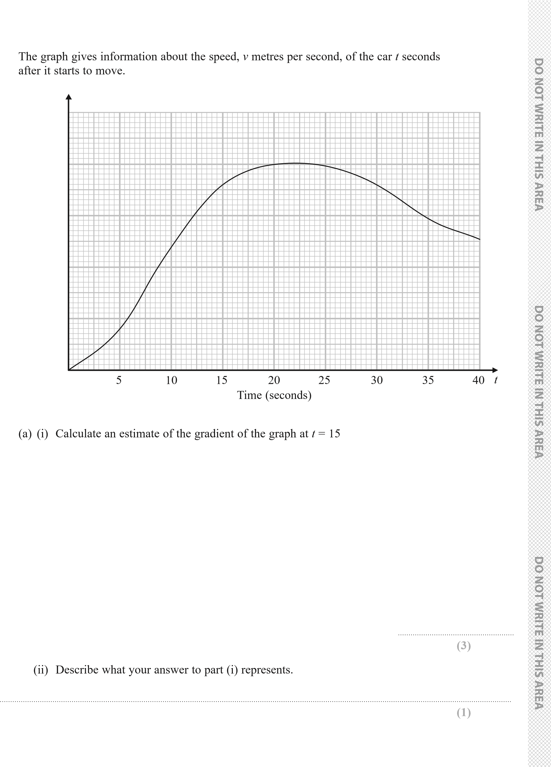A car moves from rest.

*v*

25

20

1. Speed

(m/s)

10

5

*O*

*P54214A01420*

(b) Work out an estimate for the distance the car travels in the first 20 seconds of its journey. Use 4 strips of equal width.

.......................................................m

## (3)

**(Total for Question 14 is 7 marks)**

**15** Make *m* the subject of the formula *f* = 3*m* + 4 *m* − 1



**DO NOT WRITE IN THIS AREA DO NOT WRITE IN THIS AREA DO NOT WRITE IN THIS AREA**

.......................................................

**(Total for Question 15 is 3 marks)**

# *P54214A01520*

**16** The straight line **L** has the equation 3*y* = 4*x* + 7 The point *A*KDVFRRUGLQDWHVí

Find an equation of the straight line that is perpendicular to **L** and passes through *A*.



**DO NOT WRITE IN THIS AREA DO NOT WRITE IN THIS AREA DO NOT WRITE IN THIS AREA**

..................................................................................

**(Total for Question 16 is 3 marks)**

# *P54214A01620*

**17** There are some small cubes and some large cubes in a bag. The cubes are red or the cubes are yellow.

The ratio of the number of small cubes to the number of large cubes is 4 : 7

The ratio of the number of red cubes to the number of yellow cubes is 3 : 5

(a) Explain why the least possible number of cubes in the bag is 88

..................................................................................................................................................................................................................................................

..................................................................................................................................................................................................................................................

..................................................................................................................................................................................................................................................

## (1)

All the small cubes are yellow.

(b) Work out the least possible number of large yellow cubes in the bag.



**DO NOT WRITE IN THIS AREA DO NOT WRITE IN THIS AREA DO NOT WRITE IN THIS AREA**

.......................................................

**(3) (Total for Question 17 is 4 marks)**

# *P54214A01720*

**18** The points *A*, *B*, *C* and *D* lie on a circle. *CDE* is a straight line.

*B*

*E*

*C*

40

°

*D*

*A*

*BA* = *BD*

*CB* = *CD*

Angle *ABD* = 40°

Work out the size of angle *ADE*.

You must give a reason for each stage of your working.



**DO NOT WRITE IN THIS AREA DO NOT WRITE IN THIS AREA DO NOT WRITE IN THIS AREA**

**(Total for Question 18 is 5 marks)**

# *P54214A01820*

**19** The diagram shows a triangular prism.

*E*

*F*

*B*

*C*

35

°

15

cm

*D* 15 cm *A*

The base, *ABCD*, of the prism is a square of side length 15 cm.

Angle *ABE* and angle *CBE* are right angles. Angle *EAB* = 35°

*M* is the point on *DA* such that

*DM* : *MA* = 2 : 3

Calculate the size of the angle between *EM* and the base of the prism. Give your answer correct to 1 decimal place.



**DO NOT WRITE IN THIS AREA DO NOT WRITE IN THIS AREA DO NOT WRITE IN THIS AREA**

.......................................................°

**(Total for Question 19 is 4 marks)**

# *P54214A01920*

**20** *CDEF* is a quadrilateral.

*C*

*D*

*F*

*E*

*M*

*X*

→ → →

*CD* = **a**, *DE* = **b** and *FC* = **a** – **b**.

→

(a) Express *FE* in terms of **a** and/or **b**.

Give your answer in its simplest form.

.......................................................

## (2)

*M* is the midpoint of *DE*.

*X* is the point on *FM* such that *FX* : *XM* = *n* : 1 *CXE* is a straight line.

(b) Work out the value of *n*.



**DO NOT WRITE IN THIS AREA DO NOT WRITE IN THIS AREA DO NOT WRITE IN THIS AREA**

*n* = .......................................................

## (4)

**(Total for Question 20 is 6 marks)**

**TOTAL FOR PAPER IS 80 MARKS**

# *P54214A02020*